**Severity: Critical**

**Bug Id**: D-1

**Title:**

Website Crashes Due to Excessive Characters in 'הערות' Section Causing Out of Memory Error

**Description:**

Entering an excessive number of characters (over 10 million) in the comment section next to an item causes the website to slow down drastically. Attempting to scroll down or click on anything results on the website crashing and displaying an "out of memory" error.

**Steps:**

1. Enter Shufersal website and login to the account: [example@gmail.com](mailto:example@gmail.com) ; password: Abc123



1. Click on the logo to open "הרשימות שלי" (top left)



1. Select the list "הרשימות שלי" choose the list "ירקות ופירות" by pressing this.
2. Click on "הערה".
3. Enter the content from the provided Word document.
4. Scroll down and up it will slow down and then crush giving this error:

**Expected result:**

The website should limit the number of characters that can be entered in the comment section to a reasonable amount, consistent with other parts of the website where the limit is 26 characters. This limit is intended to prevent performance issues and ensure usability across all sections of the site.

**Actual result:**

The website slows down drastically and then crashes with an "out of memory" error after entering an excessive number of characters in the comment section.

**Notes & attachments**

Notes:

Potential for Exploitation: This bug can be exploited to cause a denial-of-service (DoS) condition, making the website unusable for other users.

Attachments:

* 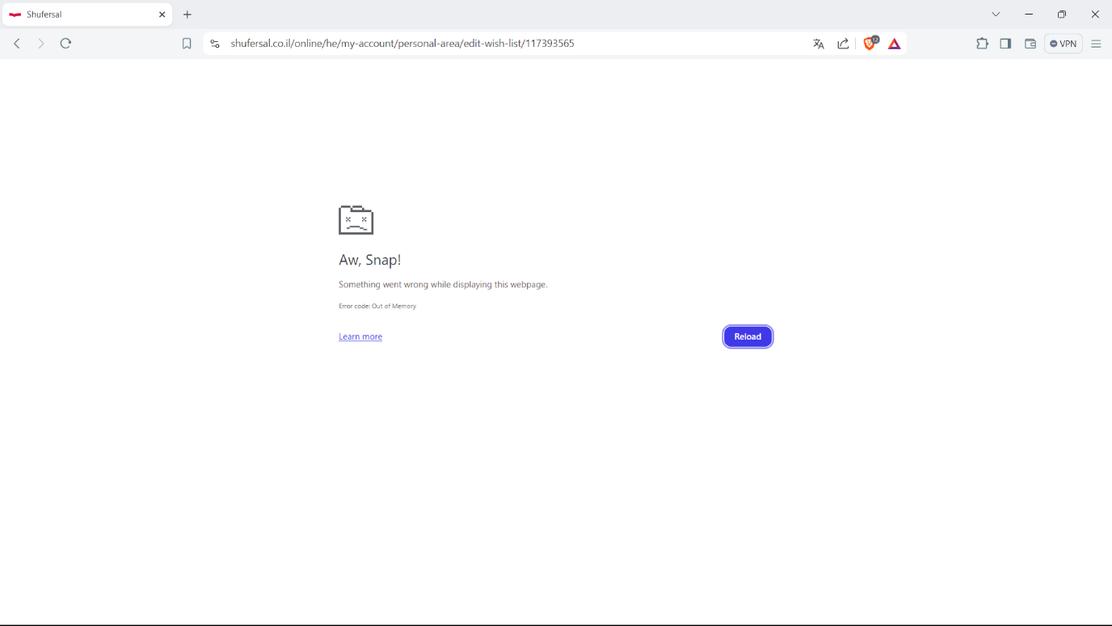Screenshots of the error message.
* File to enter "הערה"



* Video demonstrating the steps to reproduce the issue.

